Tsebo Letele Favour Ajayi

ST10364068 ST10022295

GROUP 3 GROUP 3

September 2, 2024

Tsebo Letele Favour Ajayi

ST10364068 ST10022295

GROUP 3 GROUP 3

WEDE6021

POE PART 1: SECTION 1

**SECTION 1**

**Introduction:**

Specializing in pre-owned luxury products, The Changing Room is a modern South African website that appeals to eco-conscious consumers in an era where sustainability is becoming more and more essential. The website functions as a consignment store where customers can purchase and sell lightly worn designer clothes, accessories, and shoes. The Changing Room reduces environmental waste in addition to offering high-end fashion at more reasonable costs by emphasizing the prolongation of the life cycle of premium products. This overview explores the website's innovative features, strengths and weaknesses, and a UX design evaluation.

**Overview of 'The Changing Room' website:**

The Changing Room is a modern South African website that sells previously used luxury goods with an emphasis on sustainable fashion. It functions as a consignment shop where clients may purchase and sell luxurious, lightly worn designer clothing, footwear, and accessories. The website strives to promote sustainability in the fashion sector by prolonging the luxury items' life cycle and so decreasing waste.  
  
Homepage: 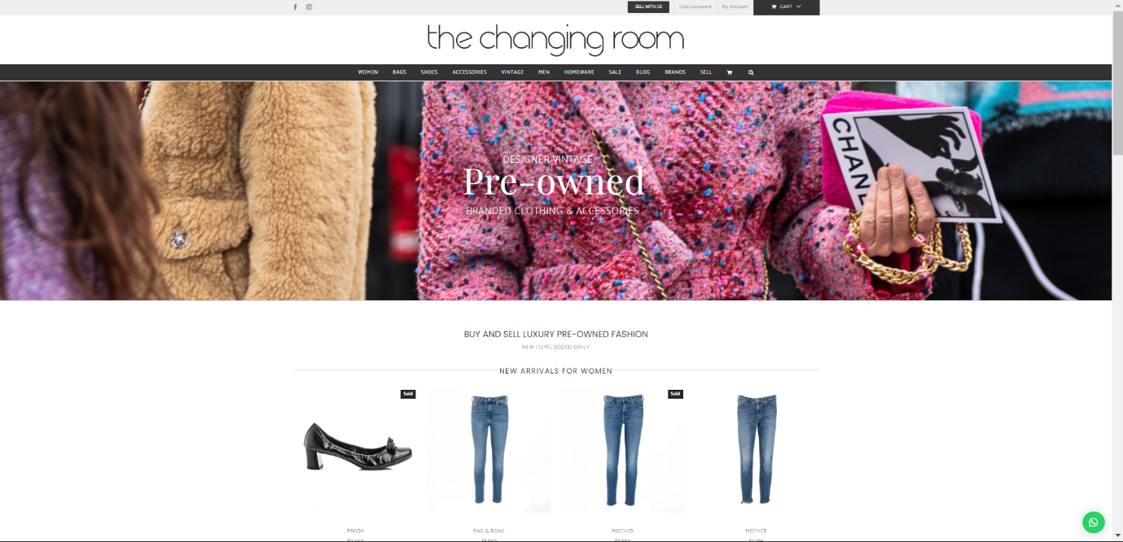

The homepage introduces visitors to "The Changing Room" with a visually appealing layout. It features a large hero image that highlights key products or promotions, followed by various sections showcasing the latest collections, featured items, and customer testimonials. The navigation is straightforward, with links to different sections like "Shop," "Women’s," and "Sale."

Women’s Section:

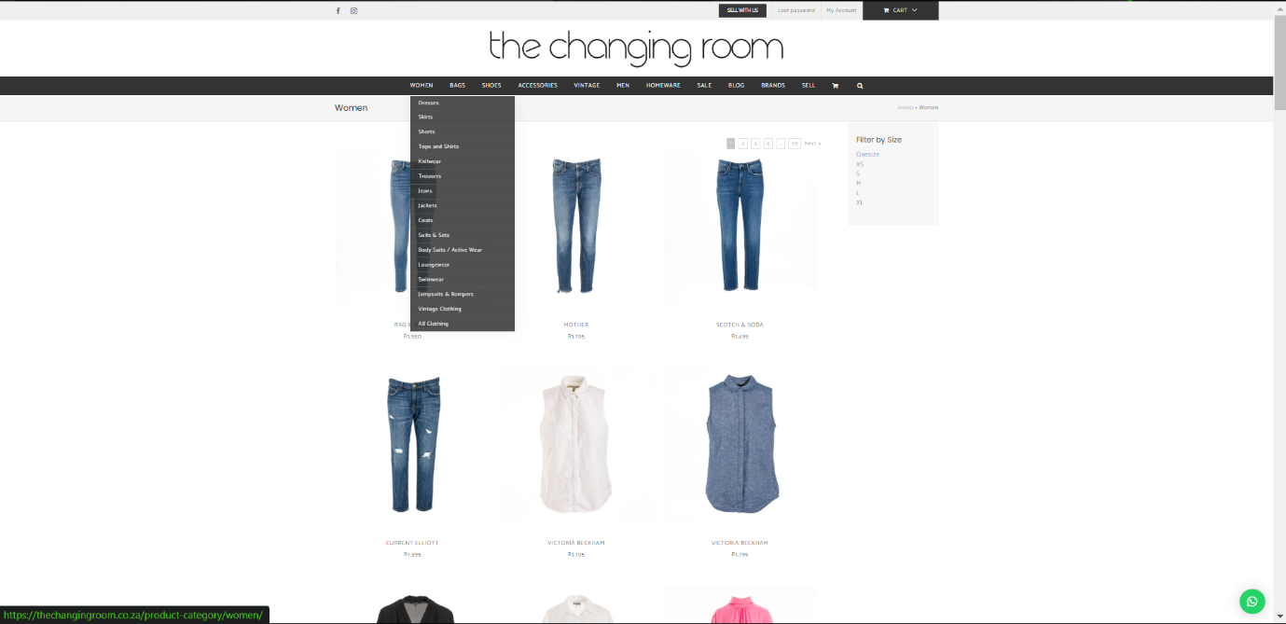

The "Women’s" section focuses on fashion offerings for women. The dropdown menu under this section provides easy access to various categories such as tops, dresses, and accessories. Each category is visually organized with high-quality images and concise descriptions, making it easy for users to find what they’re looking for.

Shop Section:

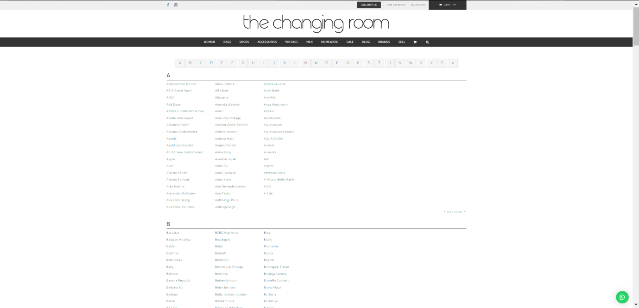

The "Shop" section is structured to allow users to explore products by categories like brands, new arrivals, or seasonal collections. Each product is displayed with a detailed image, price, and a brief description. This section is crucial for guiding users through the shopping process, making it user-friendly and efficient.

Sale Section:

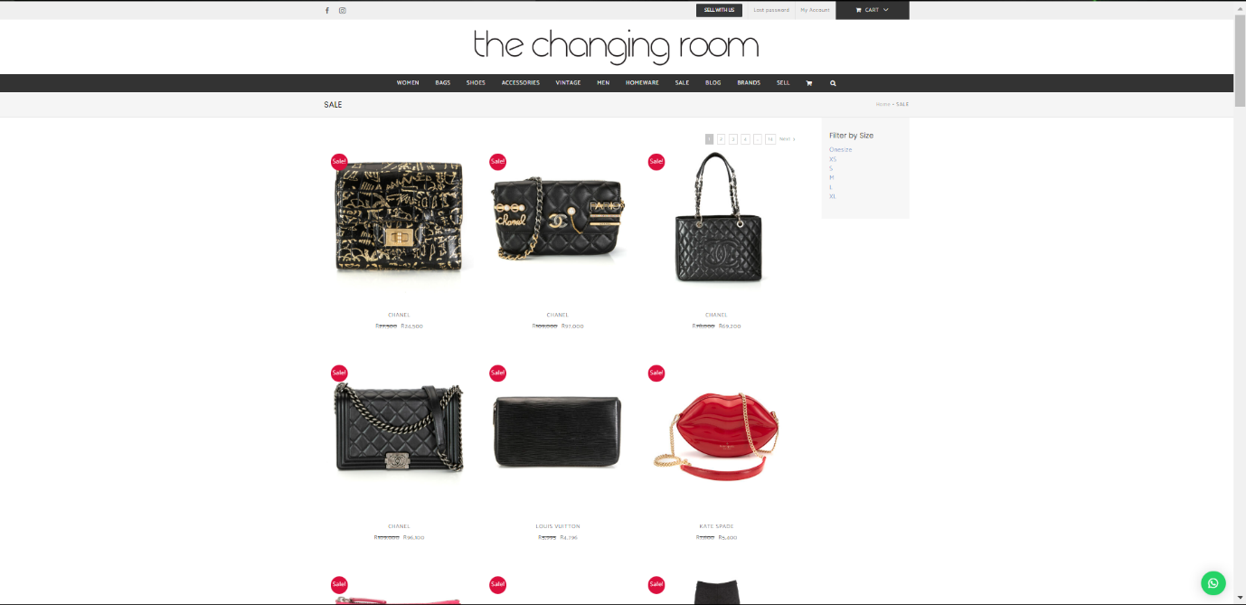

The "Sale" section highlights discounted items, making it an attractive area for bargain hunters. Products are displayed similarly to the shop section, with clear indicators of the original price and the sale price. The layout is designed to draw attention to limited-time offers and deals.

Blog:

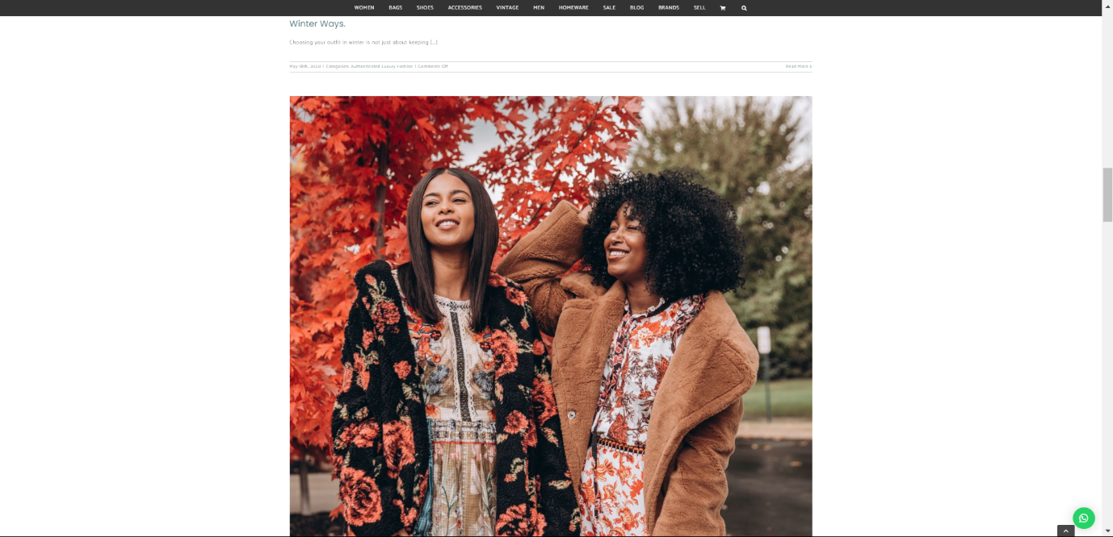

The blog section is designed to engage visitors with content related to fashion trends, styling tips, and news about "The Changing Room." This section serves as a resource for customers, providing added value beyond just shopping.

Cart:

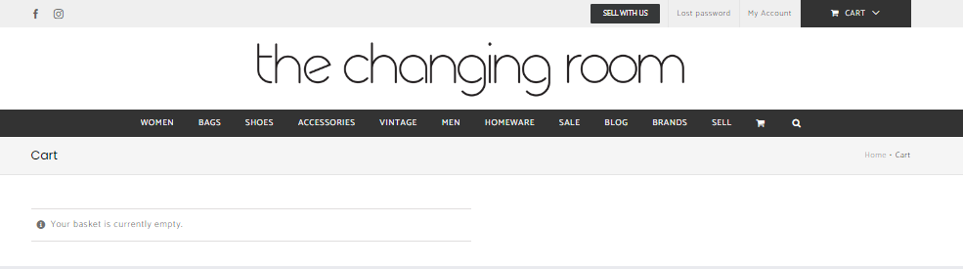

The cart section provides a clear overview of selected items, including product images, quantities, and total prices. It’s easy to navigate, allowing users to update their selections or proceed to checkout smoothly.

Sell:

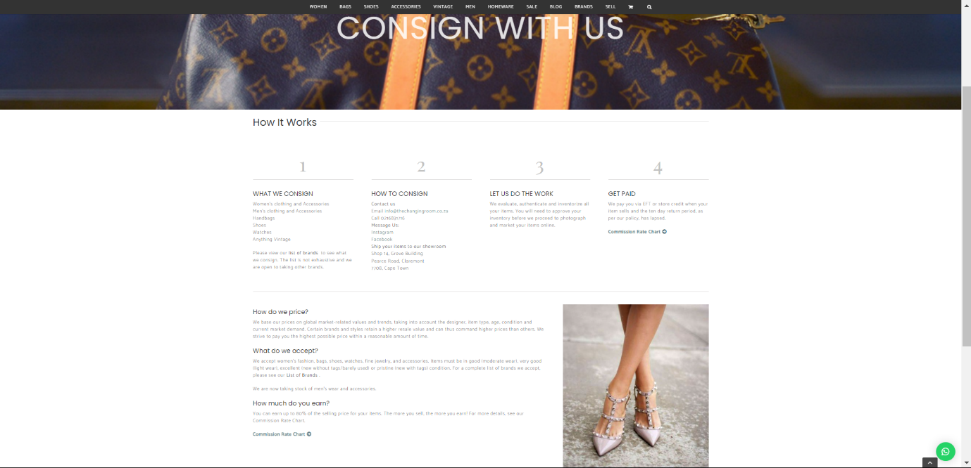

This section is likely where users can sell or exchange items, making the platform more interactive and community-driven. Details about how to list products, manage sales, and communicate with buyers are likely provided here.

Search Bar:

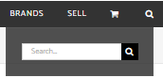

The search bar is prominently located, allowing users to quickly find products or content by typing in keywords. This feature enhances the usability of the website, making it easier for visitors to locate specific items or information.

|  |  |
| --- | --- |
| **Strengths** | **Weaknesses** |
| Sustainability: By emphasizing the resale of high-end goods, The Changing Room encourages environmentally aware fashion and helps to cut down on waste that harms the environment. | Price Sensitivity: Although luxury goods are now on sale, some customers may still find the pricing to be quite excessive. |
| Quality Assurance: By guaranteeing the legitimacy of every item, the platform gives customers peace of mind about their transactions. | Stock Variability: As a consignment store, the availability of items can be inconsistent, and popular items may sell out quickly. |
| Large Selection: It provides an enormous variety of products that appeal to both men and women, including several well-known brands. | Limited International Reach: The platform primarily targets the South African market, which may limit its appeal to international customers looking for similar services. |

**Innovative Features:**

Consignment:  
The Changing Room is unique in that it offers a consignment concept that lets customers sell their pre-owned designer products in addition to buying luxury goods at reduced prices. This concept encourages customers to engage in sustainable behaviours and is in line with the developing circular fashion trend.

Blog:

By creating a blog section, they may communicate with consumers and optimize their website for search engines. It enables information and updates from clients and the business.

**UX Design Evaluation:**

Mobile friendliness: With a responsive design that works well on a range of screen sizes, the website is mobile-friendly.

Clutter: The website keeps its layout simple and orderly, preventing clutter and allowing easy user navigation.

Load Speed: The website loads quickly, making for a seamless and delay-free experience.

Hyperlinks: Every hyperlink that has been tested on the website works properly and takes visitors to the correct pages.

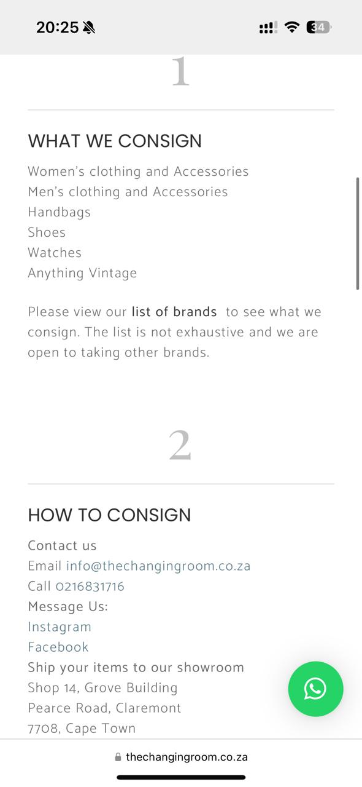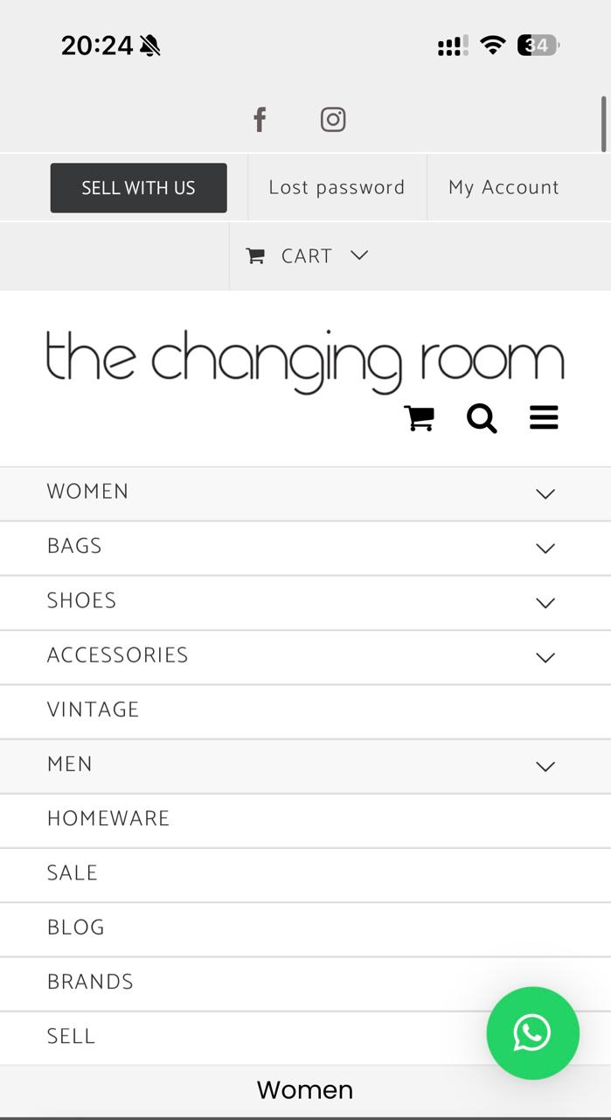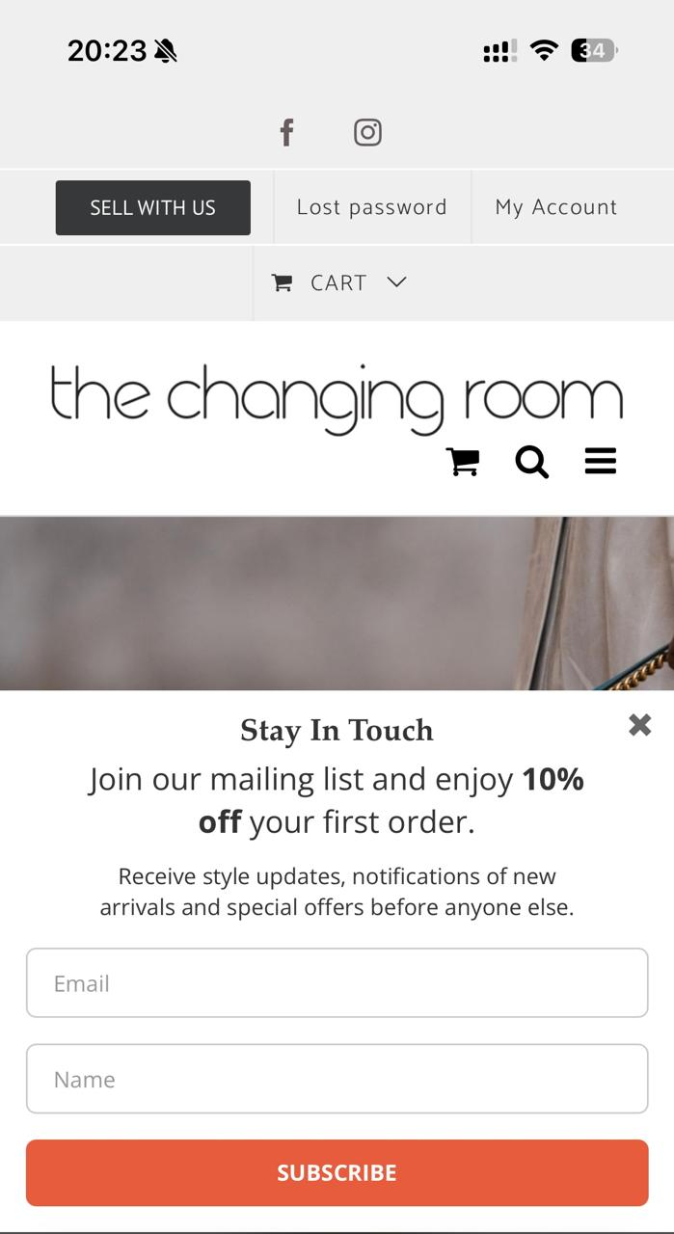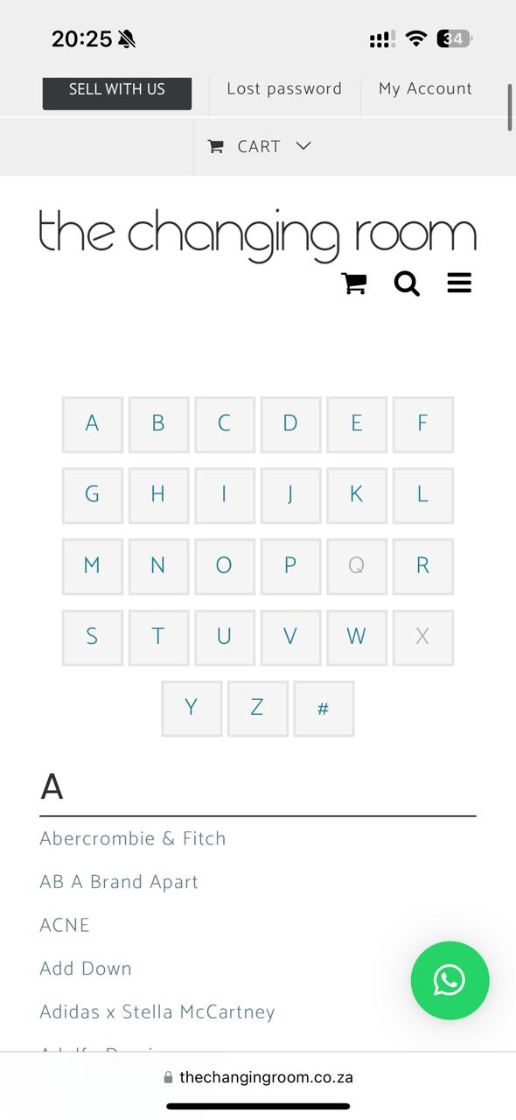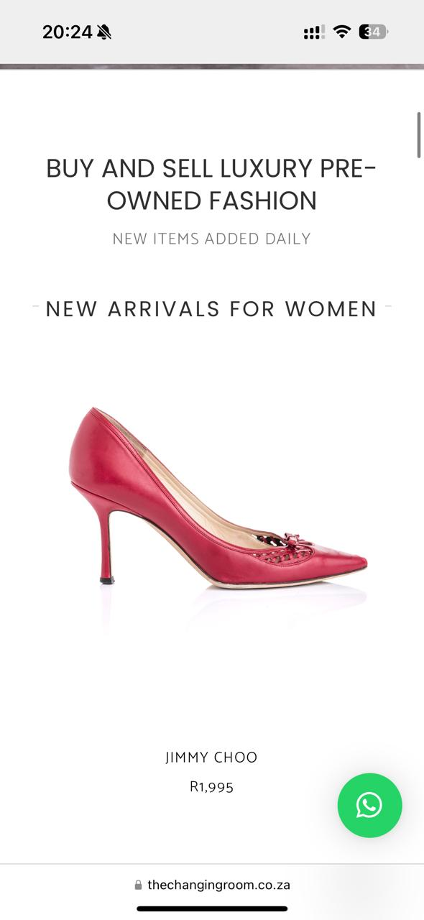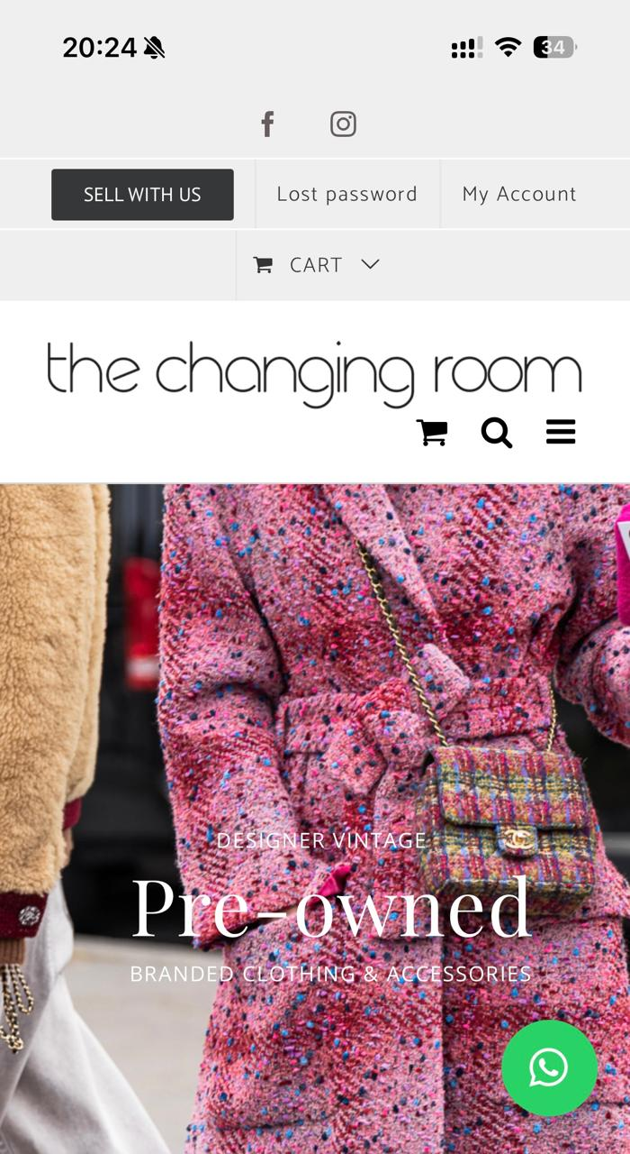

**Introduction:**

The internet has a simplified and made process of trading, selling and buying items. There is now little need to onto any item for an extended period of time. People have used this opportunity to created websites, applications, companies, or platform where individuals can buy and sell items used or pre-new. We will use two websites to understand their general purpose, strengths, weakness, features and UX design and innovation.

The evaluation will guide us in development of our own website. We will use the research done to determine the best practice to analyse the website layout and add the strengths to be effective to the website.

**Overview of The Thrift:**

The website thrifts is an e-commerce platform that looks into offering second hand clothing for women, with a focus on a particular type of fashion and focuses on tops, Thrift is an online store based in south Africa, which ensure it is affordable, has a wide style rand and sustainable fashion option provided for women.

The platform provides to individuals who are in search for clothing, taking in consideration of both cost and effectiveness and are eco-conscious. By providing and selling this goods, Thrifts not only supports sustainable fashion but also help customers find the opportunity to find trendy items at a lower price compared top clothes which are branded. The website’s mission is to make fashion more accessible and ensure while being accessible they promote friendly shopping environment.

**Homepage:**

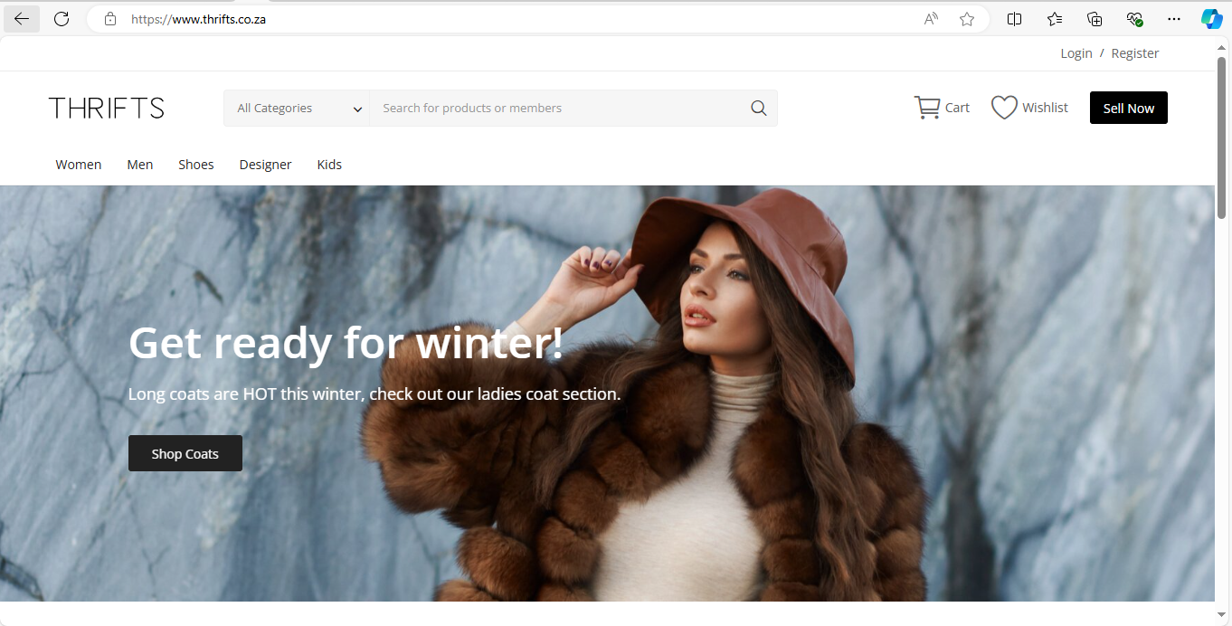

The purpose of the homepage, it is an entry to the main website, it basically shows the features, promotional pictures of the website, the categories and highlight of current sales or latest arrivals.

Features

The clothing shop features a drop-down menu that present a well-organized list of categories for user to users to choose. This simplifies the process for customers to explore clothing items that match their liking allowing them to browse through various categories and view the available option for sales.

**Women’s Page:**

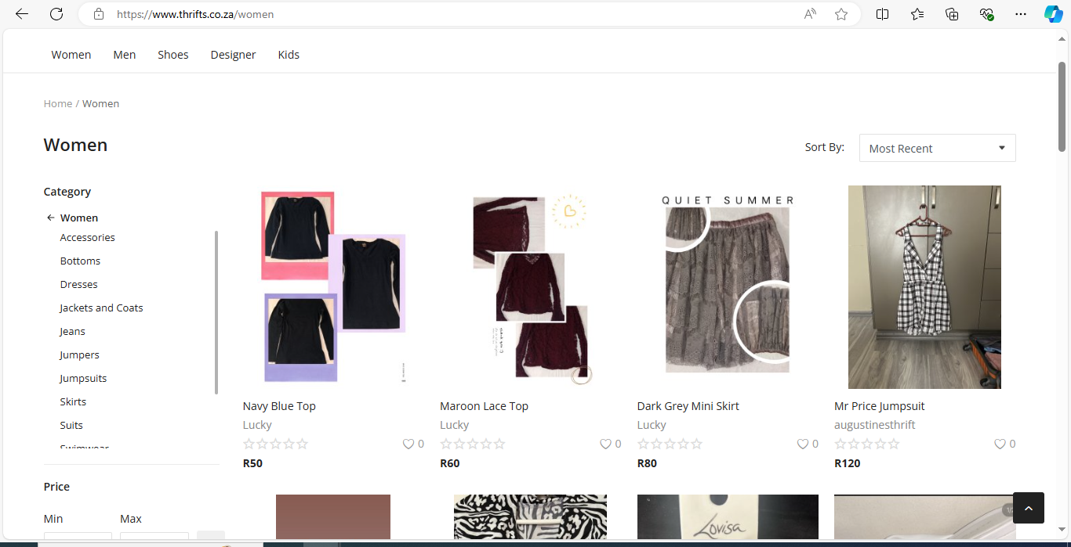

Purpose: This page specifically showcases the collection of second-hand tops for ladies. It is designed to help browse and find tops that suits their type.

Features: The page includes:

Filter: Options to clarify search based on color, size, and price range.

Product Listing: Thumbnails of tops with brief description, sizes and colour, etc. Each listing often adds clickable link to detail product page.

This also includes the categories of the what women will be interested in, showing the different sections to pick from and their prices.

**Men’s Page:**

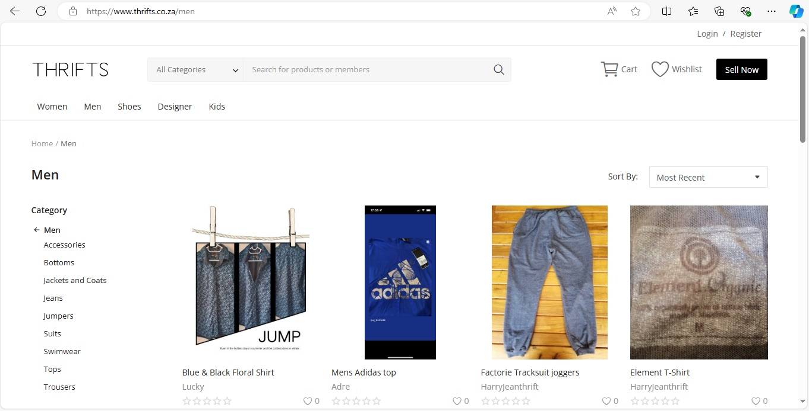

The men’s page is a page that showcases second hand clothing for men this includes categories and sub-categories such as accessories, shirts, pants etc the product displays images and description with the prices and size.

**Kid’s Page:**

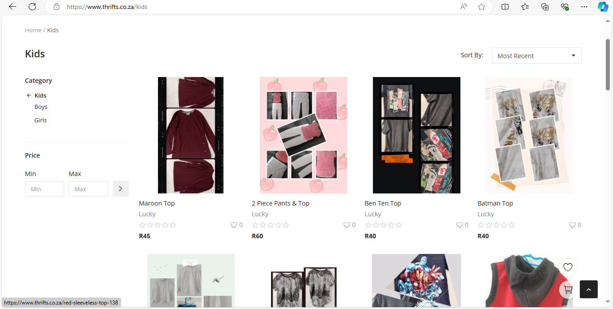

The Kid section includes categories that show outfits for children, babies, and toddlers these are displayed with items with images, description of the outfit and the prices

**Designer’s Page:**

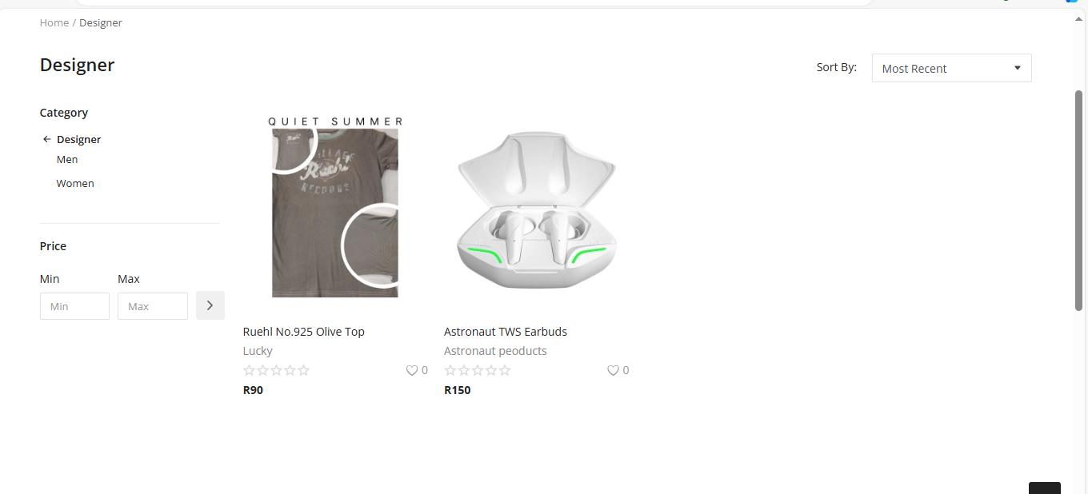

The branded section is a collection of branded goods, this are second class high branded goods, they feature the brand name etc.

**Shopping Cart’s Page:**

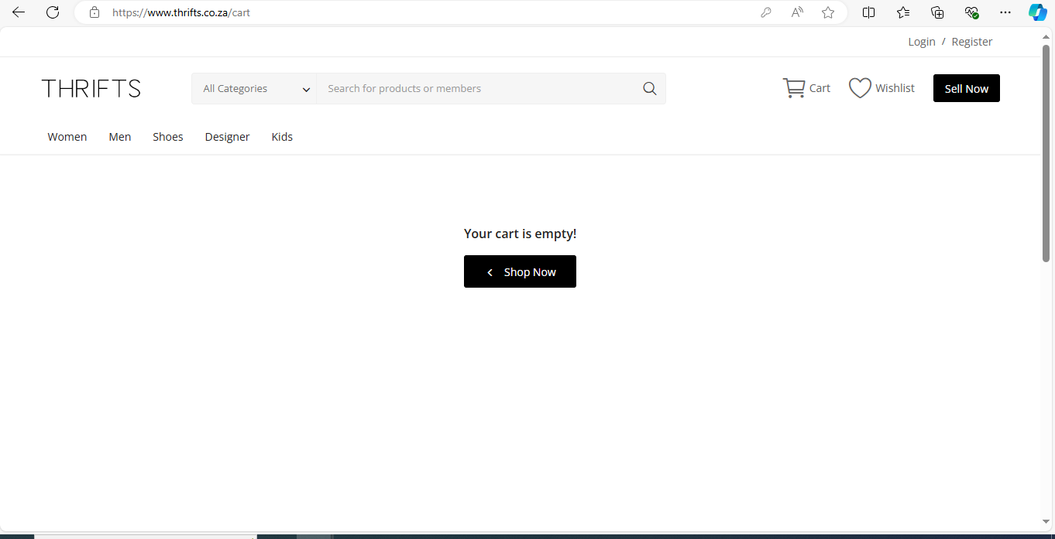

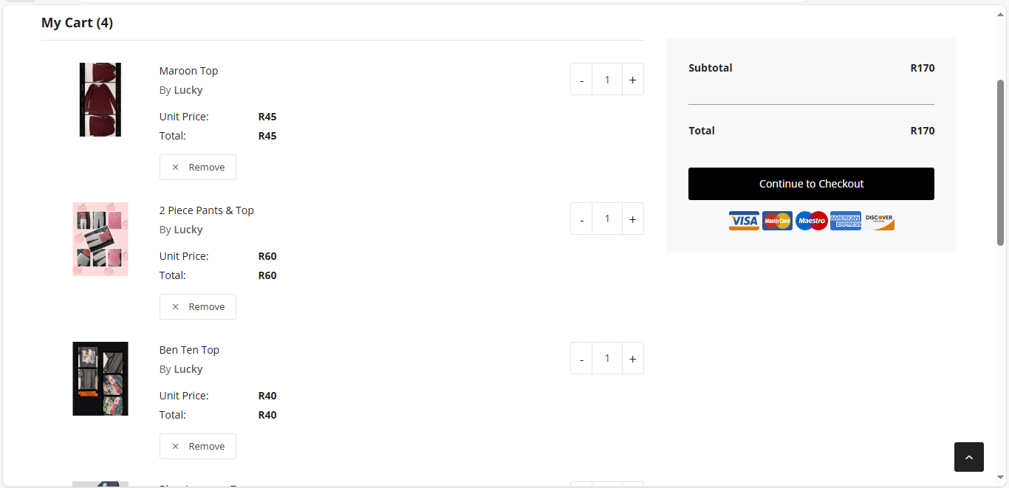

The Shopping cart page allows users to be able to review and check for products which are added for make minor changes if the user wants to add or remove items from the cart, it includes the total amount of items added, prices the sub total, and the total after tax and shipping cost, then it goes straight to the check-out page.

**Check-out Page:**

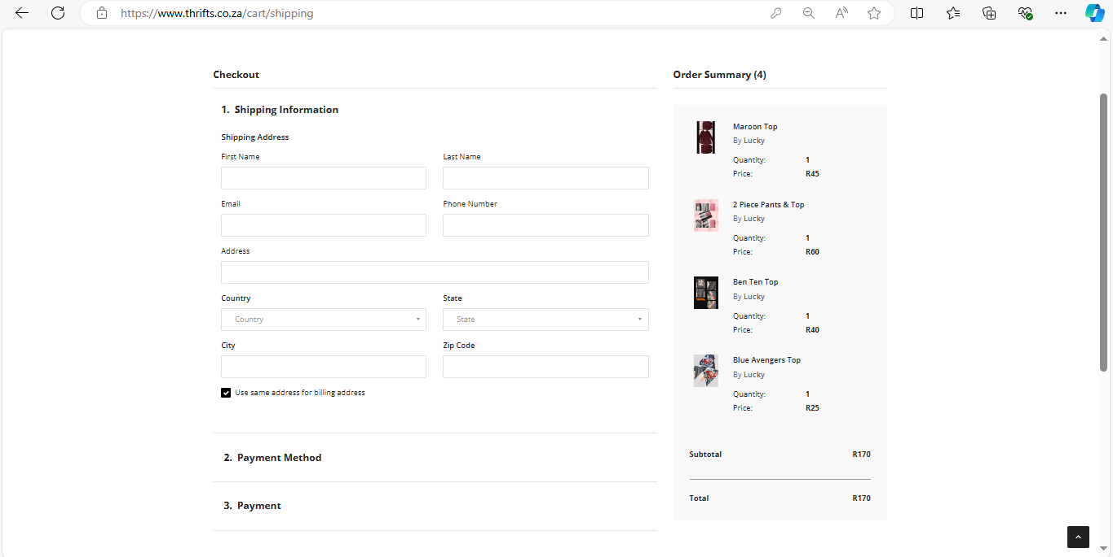

The check out page helps to organize the clothing and shows the total of the price, provides a space for shipping information, and where the user will pay

**Contact us Page:**

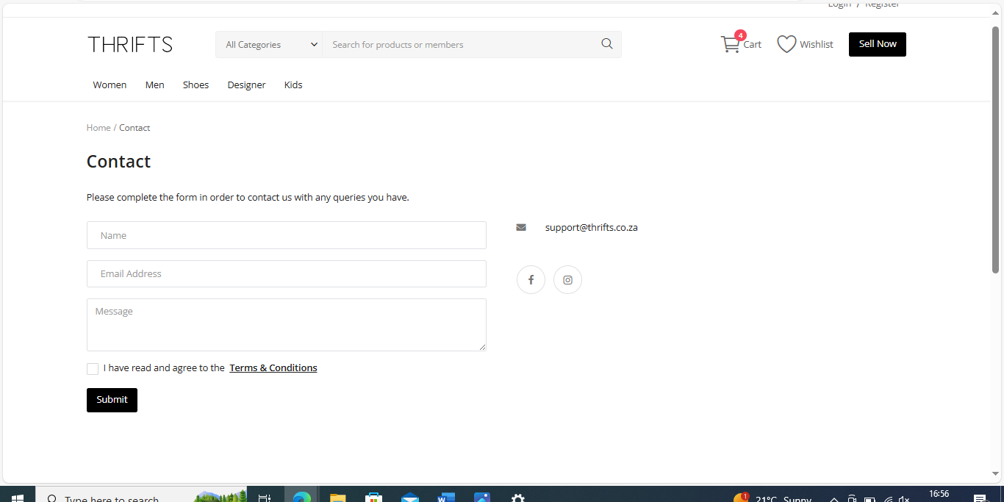

The contact us page is used to ensure in case of any problem that arises customers can reach out to the company, if payments are not going, or if package had not arrived.

|  |  |
| --- | --- |
| Strengths | Weaknesses |
| Cost-Effectiveness: The store often offers products at prices which are affordable which makes it cost effective | Inventory Variability: This shows the inconsistence with stock, or specific items which can be difficult for customers |
| Sustainability: By promoting the reuse of goods, and reducing the amount of waste | Quality Control: Items and their conditions may vary, which can be an issue and create customer dissatisfaction which can have a negative effect |
| Unique Finds: the store has unique clothing from branded too normal | Limited Online Presence: The retailor might not always be online to receive orders and reach out to customers which can have a negative effect. |
| Community engagement: The local store often fosters the involvement of the community. | User Experience: Once the website or store organization is poor it will have a difficulty level of navigating to find what is needed. |

**Innovative Features:**

* Enhanced Search and filter Option: The search functionality allows users to filter items buy the condition, brand, prices etc which helps user experience.
* Sustainability Tracking: This helps the environment impact of purchasing second-hand goods, this are features which are eco-friendly and conscious to shoppers.
* Personalized recommendations: This is driven based on past shopping, users will see recommendation on what the users has bought before and similar items they will like.
* Community Features: In this aspect, engagement such as reviews, and interaction with the platform helps to create a more engaging platform.

**User Experience:**

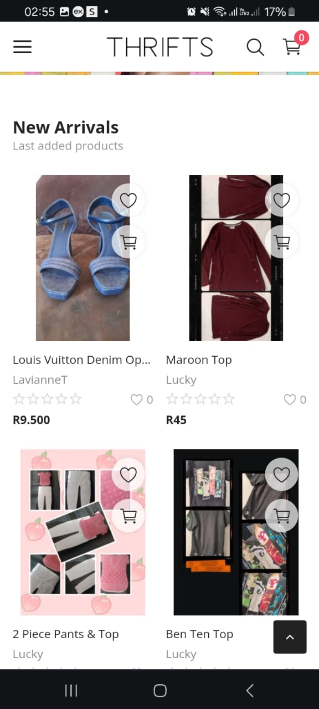

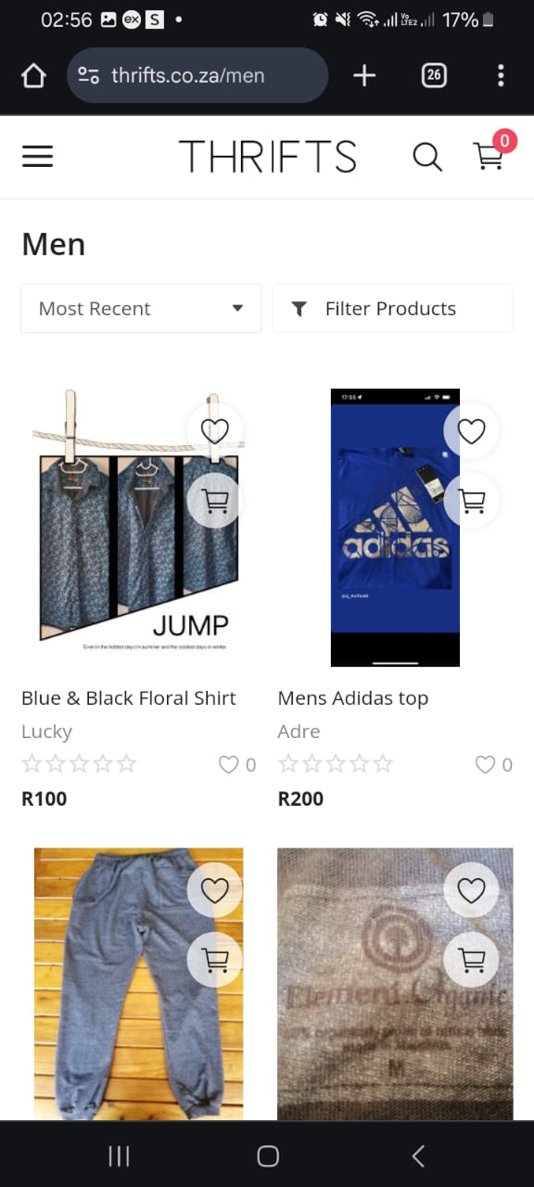

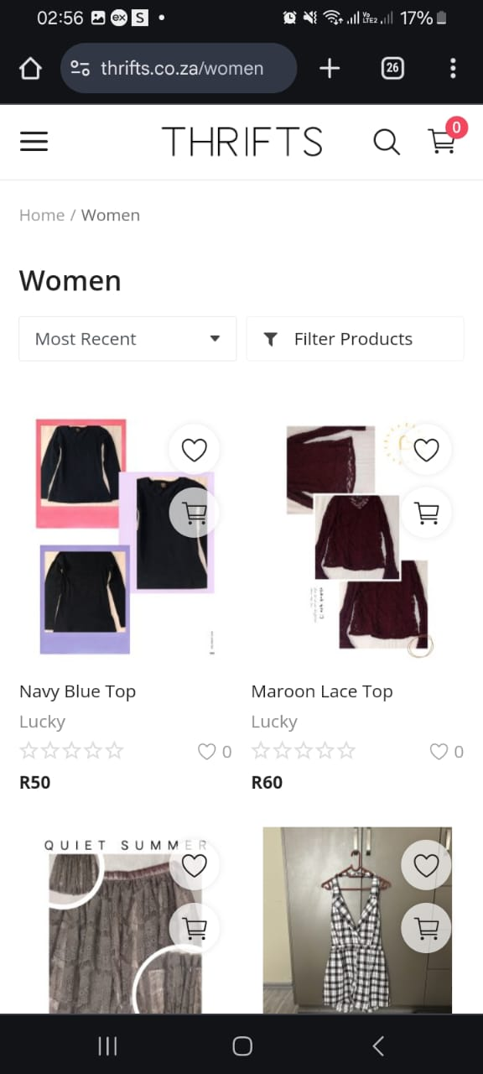

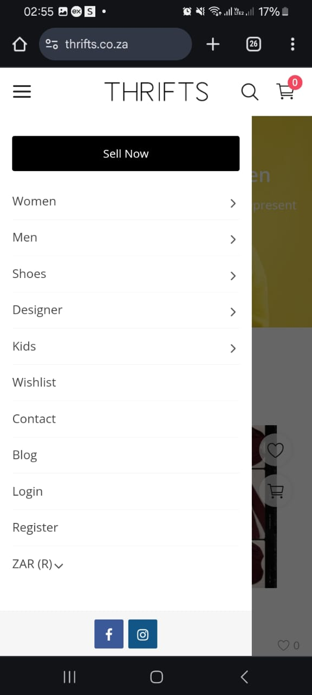

**UX Evaluation:**

* Easy Navigation: This helps users easily navigate through the listed categories, the search is seen and filter helps to see result easily.
* Mobily Friendly: The design caters to ensure each device both android and apple is catered for and the functionality can be seen, laptop and phones can view the site according to how the screen is seen.
* Fast Load Time: The time at which the pictures and script of the website at which it load is fast which is perfect for users overall.
* Readable Text: Fonts and appropriate and visible colours and alternative and contrast text can be seen and it improves user experience.

**COMPARISON**

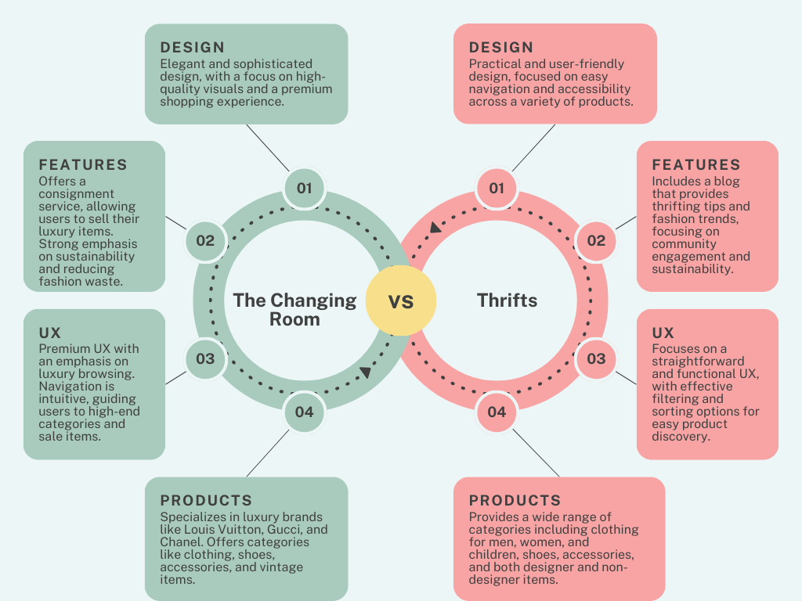

**List of Best Features**

* Sustainability Tracking:

This helps the environment impact of purchasing second-hand goods, this are features which are eco-friendly and conscious to shoppers.

* Personalized recommendations:

This is driven based on past shopping, users will see recommendation on what the users has bought before and similar items they will like.

* Consignment:  
  The Changing Room is unique in that it offers a consignment concept that lets customers sell their pre-owned designer products in addition to buying luxury goods at reduced prices. This concept encourages customers to engage in sustainable behaviours and is in line with the developing circular fashion trend.
* Blog:

By creating a blog section, they may communicate with consumers and optimize their website for search engines. It enables information and updates from clients and the business.

* Search Bar:

Because it makes it easier for users to access information than traditional navigation menus, a search bar might be regarded as the best feature. Users may get a list of all relevant information on the website by only inputting a few keywords. It can save consumers a great deal of time and work.

**CONCLUSION**

Through an analysis of these two websites, we have been able to determine how important it is for our e-commerce website's layout to ensure that consumers are effectively marketed with our items while taking into account their strengths and weaknesses, UX design, and new features. In this manner, appropriate guidelines are outlined for us, enabling us to develop well-built, visually appealing, and user-friendly websites for used clothing.

# References

Room, T. C. (2023). *The Changing Room Home Page*. Retrieved from thechangingroom: https://thechangingroom.co.za/

Thrifts. (2022). *Thrifts Home Page*. Retrieved from thrifts: https://www.thrifts.co.za/